**Git hub guide - How to Start with the github**

1. Firstly go to a folder where you want to clone the github repository. In our case it is the folder sample code

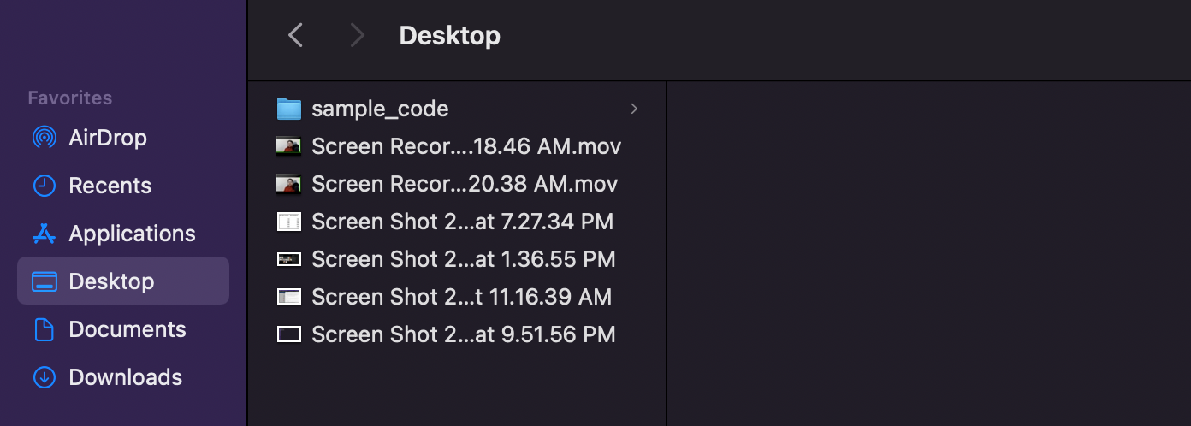

1. Open the Terminal on your mac from the spot light finder

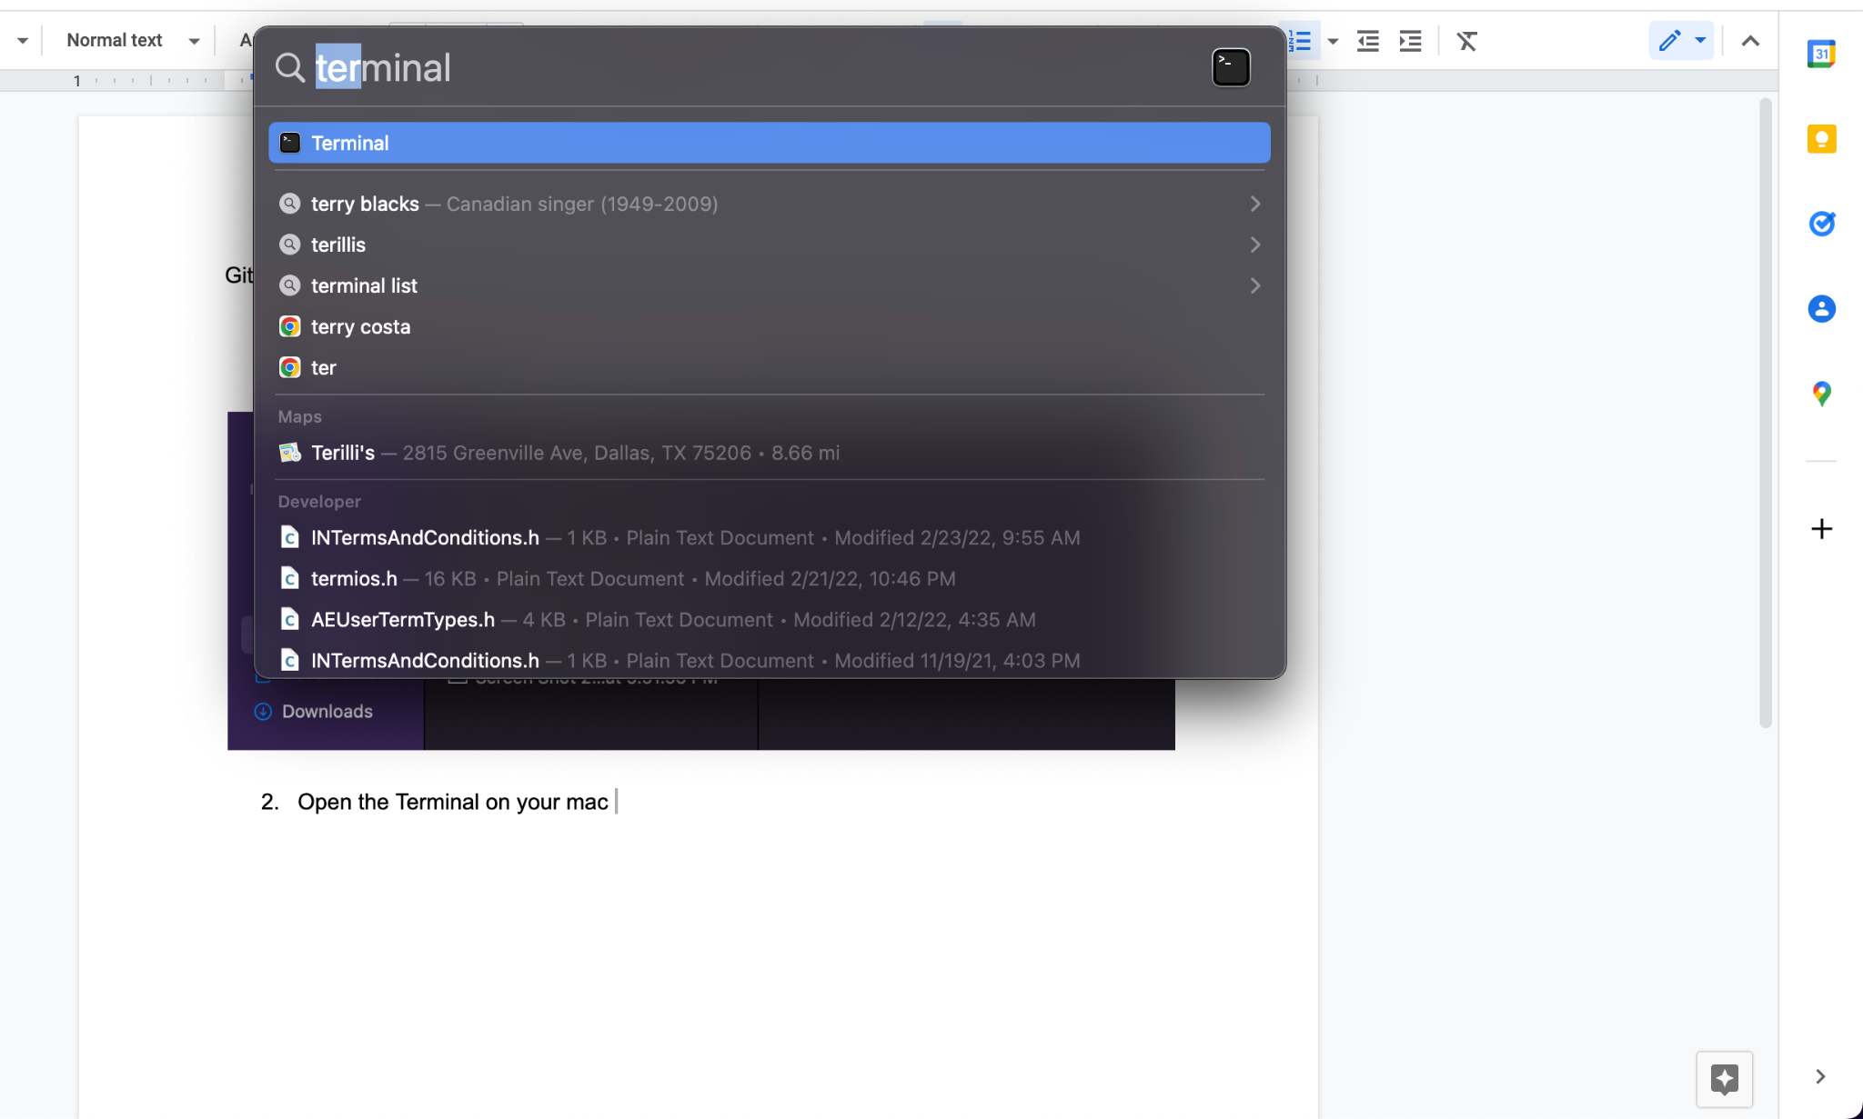

1. Once the terminal is open type command “git –version” to check if you have the git installed or not. If it is not installed then macbook will ask you to install xcode and developers tool. Simply install them as they will provide the github
2. Once your xcode and other developer softwares have got installed then again type the same command on the terminal “git –version” if you see the results then that means now you have the git installed on your laptop

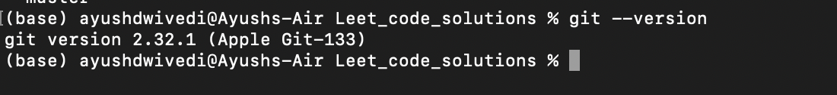

1. Now once you know that the git is installed in your laptop you can simply go to the folder where you want to clone the repository

ls - to see what contents are present in your current folder



Now use the command “cd <folder name>” to reach the folder where you want to go

So here we do “cd sample_code”

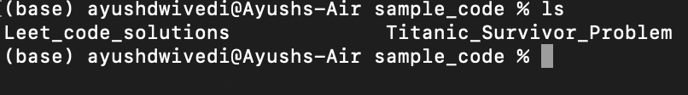

Now we are inside the folder where we want to clone the repository

1. Now the next thing that we need to do is create a “ssh key” so that we can directly fetch the code from the remote repository and push the code to the remote repository without any issues.

So we type the command “ssh-keygen”

Once this command gets executed then you will be asked to Enter passphrase - Simply press enter

Next you will be asked Enter same passphrase again - Simply press the enter again

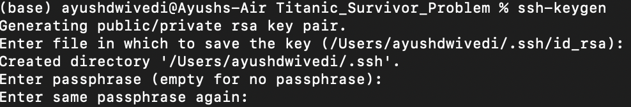

Now you will see the ssh key generated and the location where the key has been generated

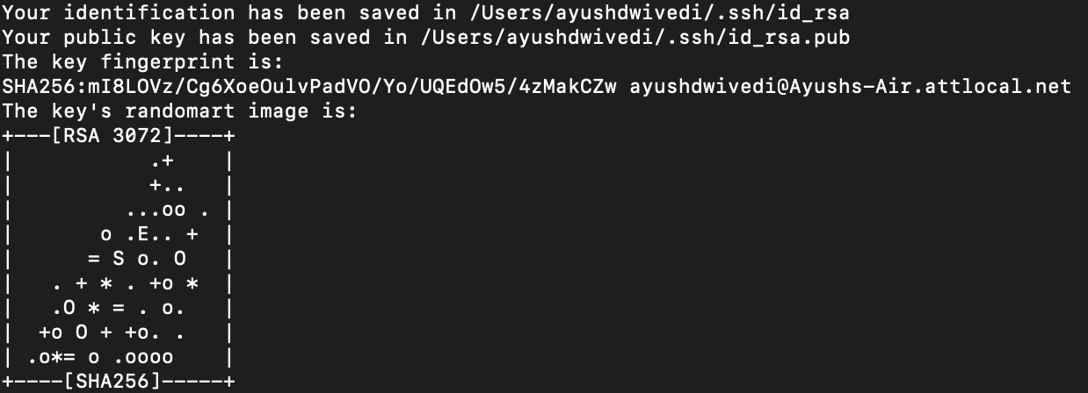

**Now you can simply enter the command “cat /Users/ayushdwivedi/.ssh/id_rsa.pub (important the you use the address of id_rsa.pub here which is the second address)**

And you will be able to see the actual key generated

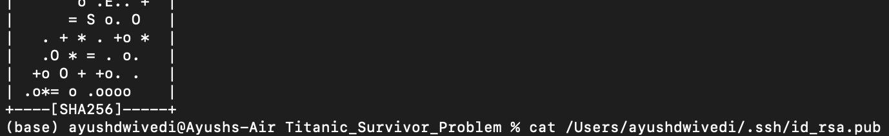

Now copy the whole key that you see- starting from ssh-rsa to .net (basically whole key)

Sample key is shown below



Now open the github account on the web browser and open github.com

Login through your credentials and come to the home screen. On the top right corner you will see a circular icon with an image. Click on it to see the options.

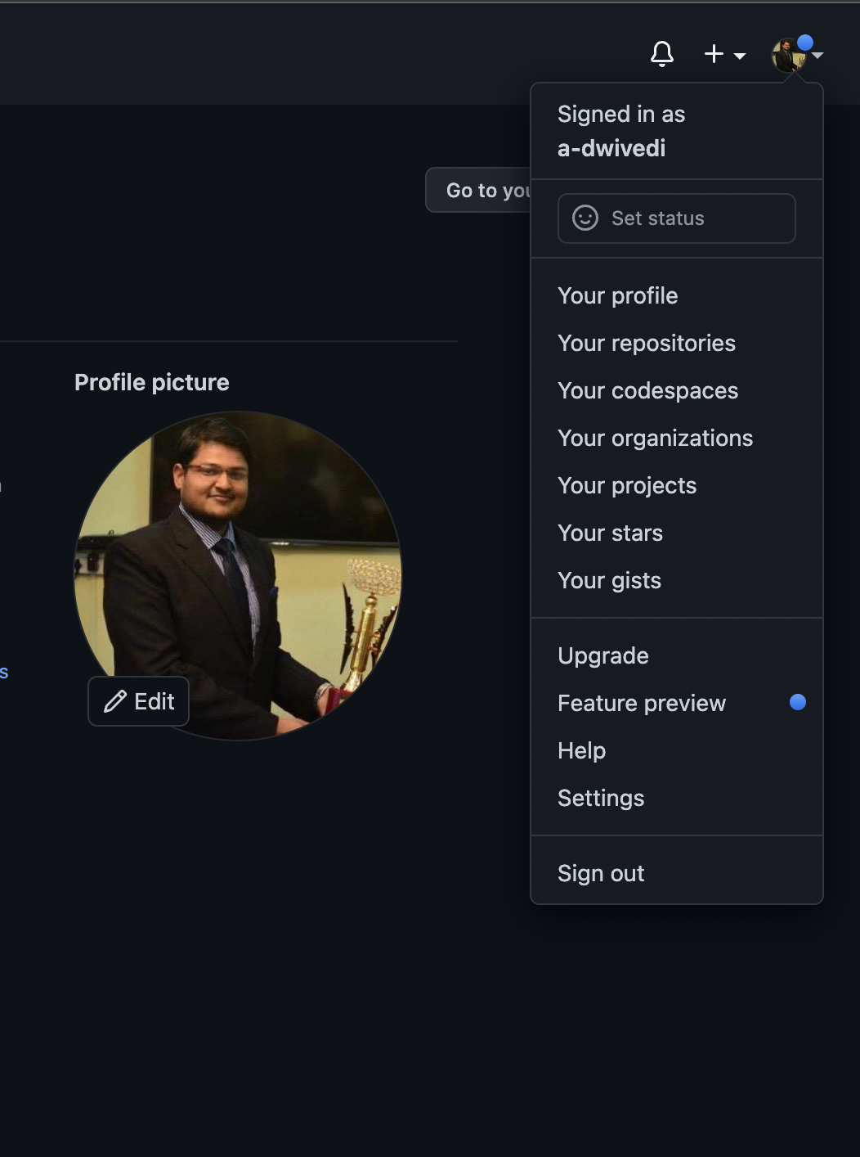

From the menu select “Settings”

Once you click on Settings there will be a new tab that will open towards the left sideof the screen

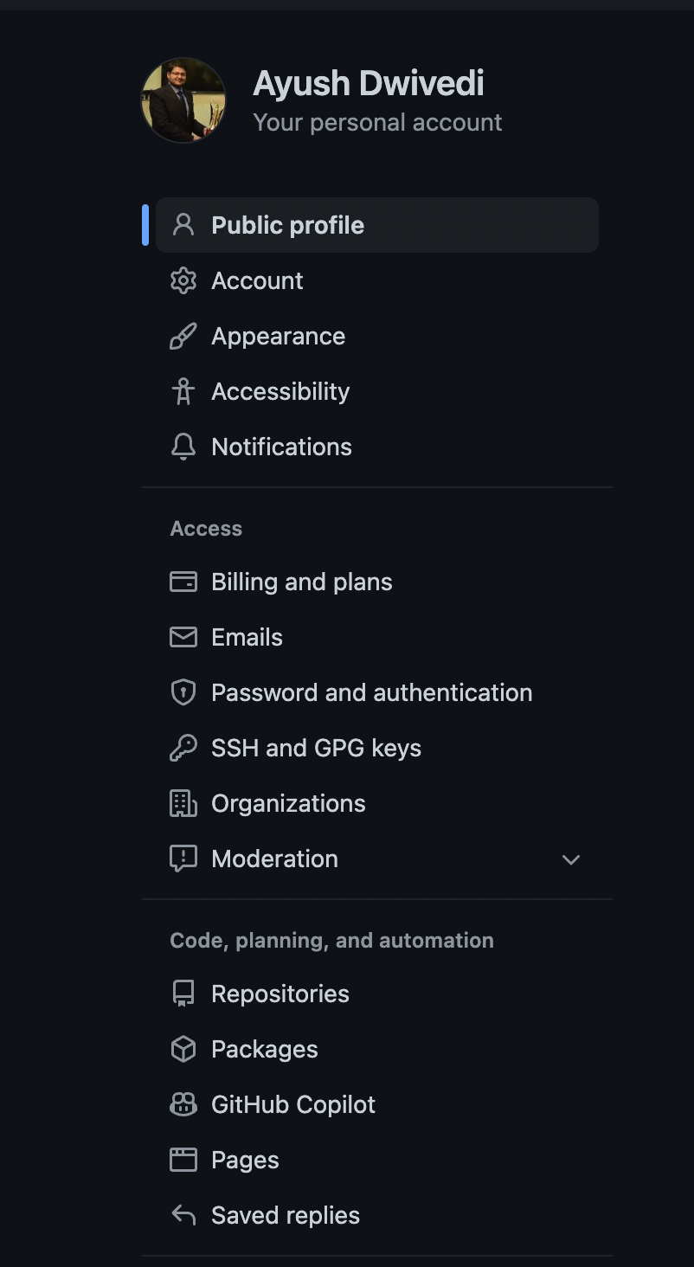

Now select “SSH and GPG keys” from the option and now you should see a screen like this

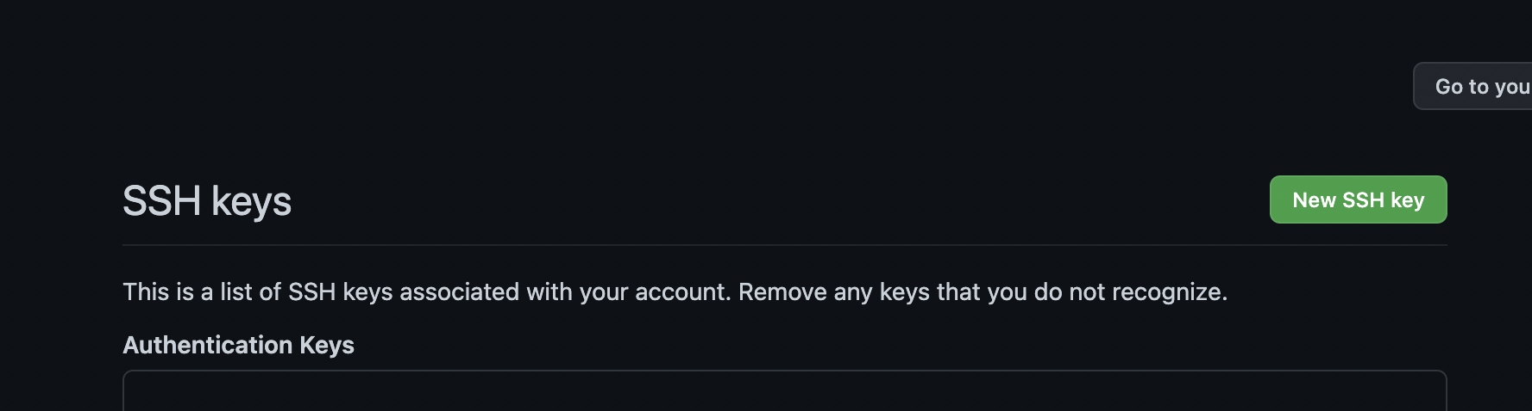

Select “New SSH Key” and then you should get an open box like the one shown below

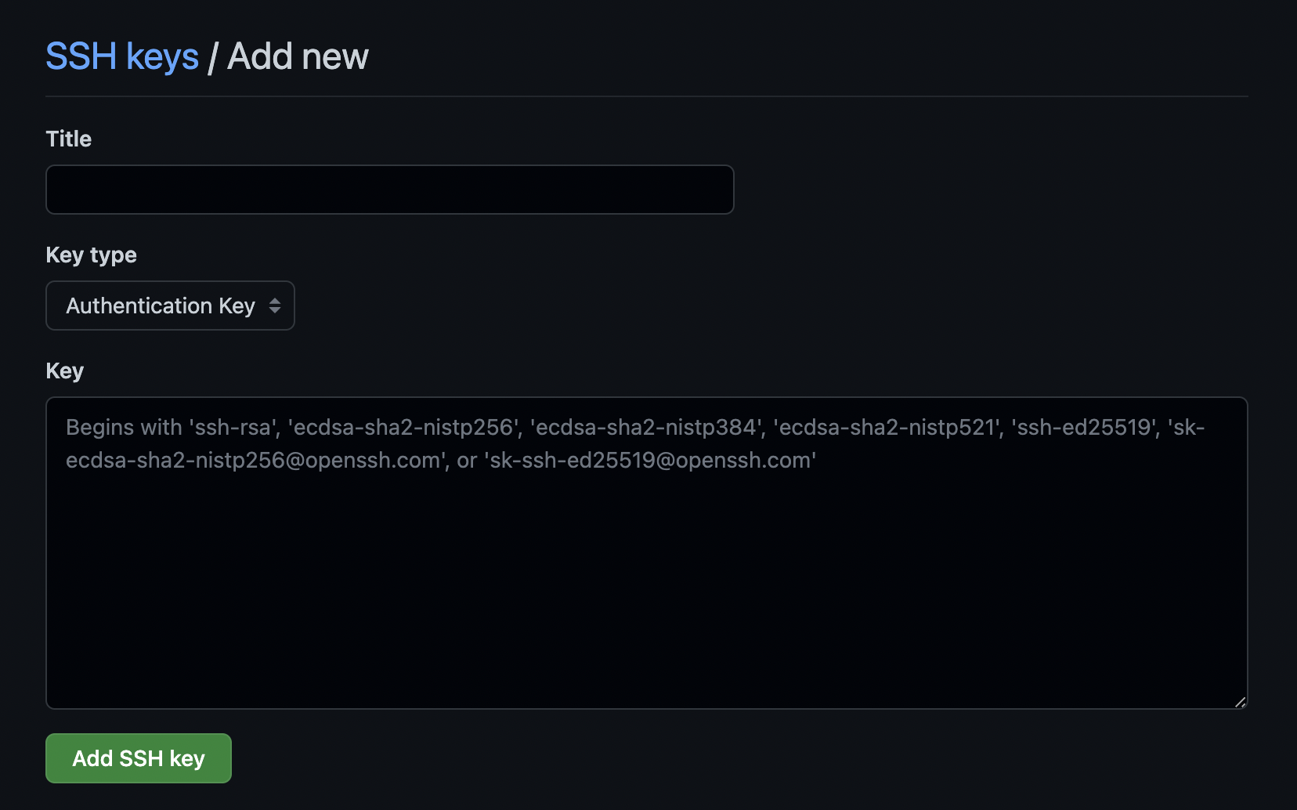

Now you can enter whatever “Title” you want and paste the copied SSH key in the “Key” section and then click on “Add SSH key “ button.

This will now add your laptop key to your github repository and then in future the git will never ask you for any login credentials.

Now go to the repository that you will like to clone. And click on the “Code” button in green. From the drop down menu select the tab “SSH” and this will give you a ssh url. Simply copy that URL. (you can see these things in the Screen shot below)

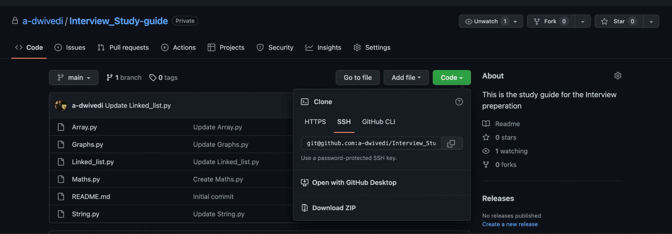

Now come back to you terminal and enter the below command

“git clone <ssh url>”

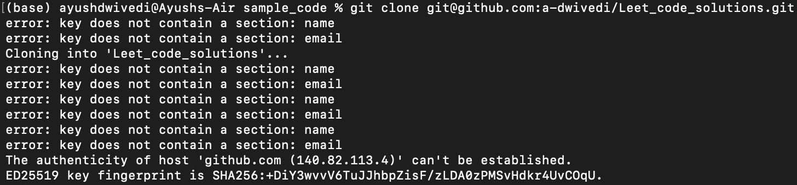

Now once you run this command the git hub repo will start cloning as shown in the image

Now we might see there is an issue that authenticity can not be established and if you come across something like this then simply type yes as shown in the image below

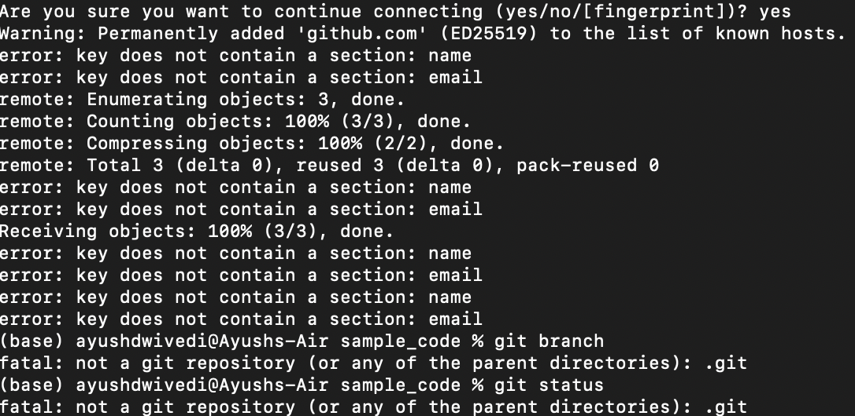

Now once the repository is cloned then you need to go inside that folder by typing the command

“cd <cloned_folder_name> “ and then once inside now you can start using your regular git commands

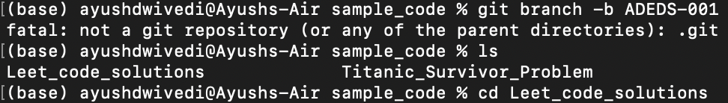

Now once inside the folder you can check which branch you are on. Use the command

“git branch”

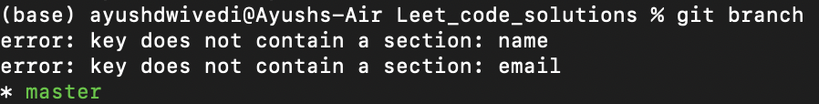

1. Now we are in the Master branch and we will not like to be on the Master branch so we create a new branch and checkout to it using the below command

“git checkout -b ADEDS-001”

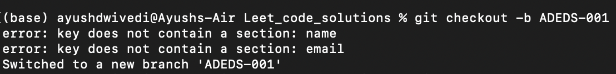

Now in our local the new branch has been created and we have switched to this new branch

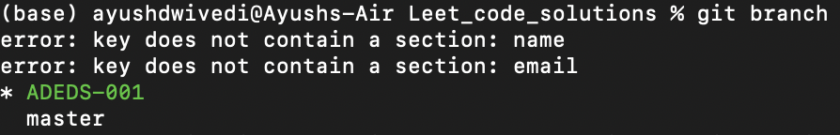

1. Now here we see there are issue of error: key does not contain a section: email

So to resolve this issue we use this stackover flow link

<https://stackoverflow.com/questions/45174228/git-error-key-does-not-contain-a-section>

Basically the issue is happening because we do not have the name and email in ./githubconfig file

So we type the command “ git config –list –show-origin” to see what are the user.email and user.name….in the screenshot below you see the actual details because it has been fixed but otherwise you will see some random value here

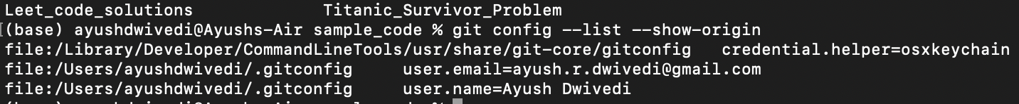

Now type “vim ~/.gitconfig” to open the vim and then you will reach the vim editor



Now the vim editor will open like this

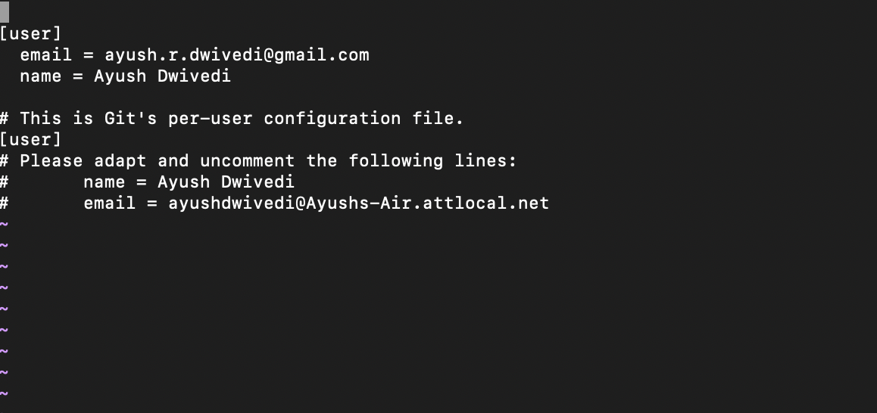

You simply Press “I” button to start typing on this editor

When it is in Insert Mode you will see “insert” in the bottom of the editor



Now add this piece of code to the vim

[user]

email = xgqfrms@xgqfrms.xyz

name = xgqfrms

Once you are done writing the email and name simply press Escape key

Then press shift + “:”

And type wq -( here w saves the work and q quits the editor)

“:wq”

Now you will see that this issue of error in email and name will get fixed.

Now do “git branch” to see which branch you are on

And that is how you can set up the github account on your Macbook . For part 2 stay tuned….